# **REPORT**

# **ON**

# **FAKE NEWS DETECTION ANALYSIS**

## PROJECT

**1. Introduction to Fake News Detection**

**Overview of Fake News**

Fake news refers to false or misleading information presented as genuine news with the intent to deceive or manipulate the audience. These news stories are typically designed to mislead readers into believing in something that is not true, often with a political, social, or financial motive. The rise of digital platforms and social media has significantly amplified the spread of fake news, with many false stories going viral in mere hours.

Historically, news outlets and traditional media were considered trusted sources of information. However, the internet and the prevalence of social media platforms such as Facebook, Twitter, and Instagram have disrupted the traditional flow of news. News dissemination is no longer filtered by editorial standards, leading to an overload of unverified information. Fake news takes advantage of this lack of control, often using sensationalized headlines and fabricated narratives to attract attention. This phenomenon has severe consequences on public opinion, political decisions, and societal stability.

The purpose of detecting fake news is not just to label articles as true or false, but to reduce the harmful effects of misinformation. Misinformation can lead to misguided actions, whether it be influencing political elections, spreading public health misinformation, or inciting violence. The consequences of not identifying fake news are far-reaching, making fake news detection a critical area of study for both researchers and the general public.

**Importance of Fake News Detection**

The importance of fake news detection lies in its ability to mitigate the negative impact of misinformation. In an age where information is abundant and rapidly shared, it becomes increasingly difficult for individuals to differentiate between what is real and what is fabricated. As a result, society is more susceptible to being misled by false narratives.

One of the most notable examples of the effects of fake news was during the 2016 United States presidential election. Fake news stories were circulated to sway voters’ opinions, often using false claims about candidates or policies. Similarly, the COVID-19 pandemic saw a surge in the spread of misinformation about the virus, vaccines, and treatment options. These instances showcase how fake news can destabilize social order and undermine trust in public institutions.

Detecting fake news can help to protect democracy by ensuring that people have access to accurate information. It can also enhance public safety by preventing the spread of harmful health-related misinformation. In the context of social media, fake news detection could improve the overall quality of content and help platforms take more responsibility for the material they distribute.

Furthermore, as people become more aware of the problem, there is a growing demand for tools that can automatically identify fake news. Machine learning offers a viable solution to this issue, automating the process of detection and providing a more scalable method of combating misinformation.

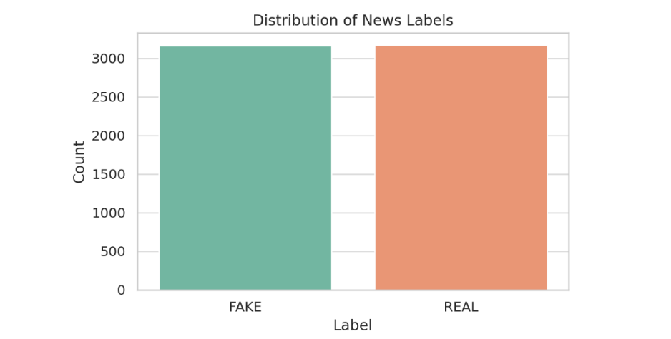

**Machine Learning in Fake News Detection**

Machine learning is a subset of artificial intelligence (AI) that allows systems to learn and make decisions without being explicitly programmed. In the context of fake news detection, machine learning models can be trained to recognize patterns in news articles and classify them as either fake or real. These patterns could be linguistic features (e.g., unusual sentence structures, hyperbole), textual inconsistencies, or even metadata like the source of the article.

The beauty of machine learning lies in its ability to improve over time. By training the models on large datasets of fake and real news articles, the system becomes better at making accurate predictions. Over time, as more labeled data becomes available, the system can be fine-tuned to improve performance.

There are different types of machine learning algorithms that can be used for fake news detection:

* **Supervised learning:** Involves training a model on a labeled dataset (fake or real news articles). The model learns from these examples and can then predict the labels of unseen data.
* **Unsupervised learning:** Does not require labeled data. Instead, it looks for patterns or groupings in the data on its own. This is useful in cases where labeled data is scarce.
* **Semi-supervised learning:** Combines both labeled and unlabeled data, allowing the model to learn from a smaller labeled dataset while leveraging a larger pool of unlabeled data.

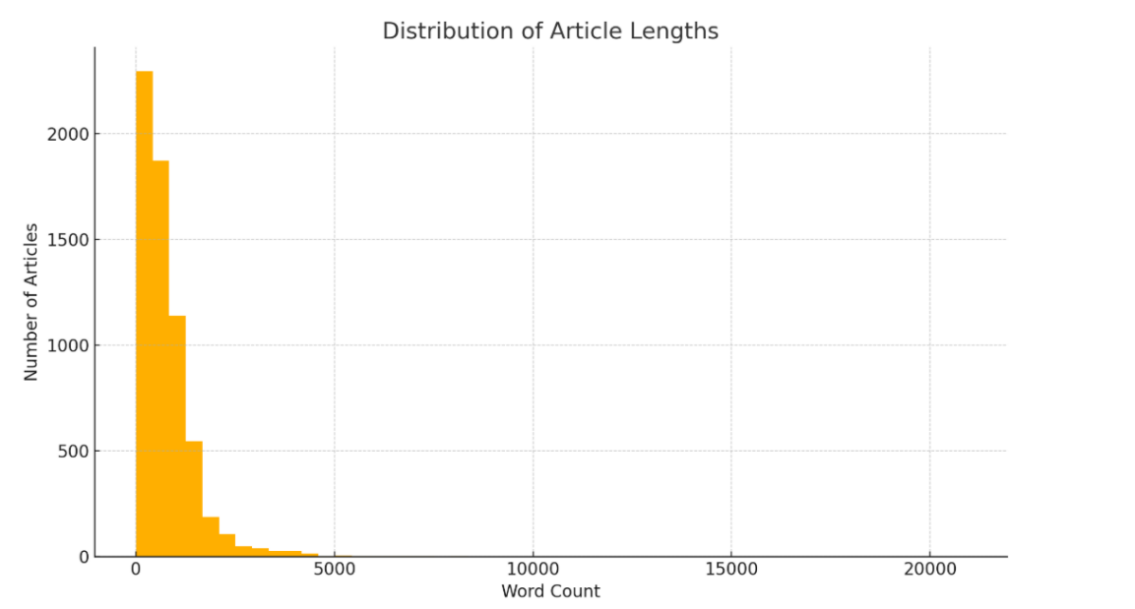

The application of machine learning in fake news detection has seen significant advancements over the past few years. Researchers have experimented with traditional algorithms such as logistic regression and Naive Bayes, as well as more sophisticated deep learning models like Recurrent Neural Networks (RNNs), Long Short-Term Memory (LSTM) networks, and Transformer-based models like BERT.

The rise of fake news presents a significant challenge to modern society, where misinformation can quickly spread through digital channels. Fake news detection is vital to maintaining the integrity of information and protecting public trust. Machine learning offers an effective way to automate the detection process, allowing systems to analyze large amounts of data quickly and accurately. The next section will delve deeper into the current state of research in fake news detection.

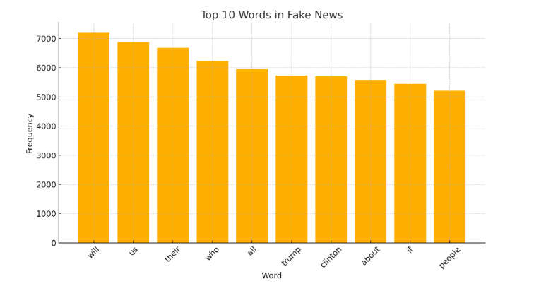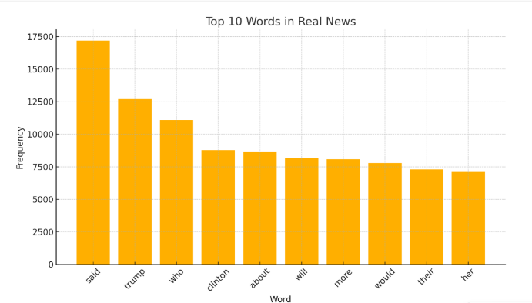

**2. Literature Review**

**Previous Approaches**

In the early stages of fake news detection, traditional methods such as rule-based systems and keyword matching were used to identify fake news. These methods, while simple, often lacked the robustness required to handle the complexity of modern misinformation. Rule-based systems relied on predefined rules and patterns to flag potentially fake news articles. For example, certain keywords like "exclusive," "shocking," or "must-read" might be flagged as indicative of fake news. However, these systems struggled to detect subtle forms of fake news or stories that were misleading but did not explicitly contain certain keywords.

With the advent of machine learning, researchers began to explore data-driven approaches. The earliest machine learning-based models relied on simple algorithms like decision trees, Naive Bayes, and support vector machines (SVMs). These models were trained on hand-labeled datasets of fake and real news articles, learning to recognize patterns based on the features extracted from the text.

A more advanced approach involves using deep learning models, which can automatically extract relevant features from raw text data. For instance, convolutional neural networks (CNNs) and recurrent neural networks (RNNs) have been employed to classify news articles. These models are capable of capturing complex patterns in text, such as semantic relationships between words, and can therefore perform better in terms of accuracy.

In recent years, transformer-based models like BERT and GPT (Generative Pre-trained Transformer) have revolutionized natural language processing (NLP) tasks, including fake news detection. These models, based on attention mechanisms, can understand context more effectively than previous models, making them highly accurate in detecting fake news.

**Challenges in Fake News Detection**

Despite the progress made in the field, there are several challenges in fake news detection. One of the main obstacles is the **imbalance of data**. In most datasets, real news articles outnumber fake news articles, leading to models that are biased toward predicting real news. This imbalance can result in low recall for fake news and reduced overall model performance.

Another challenge is the **linguistic complexity** of fake news. Fake news articles often use subtle manipulations of language to mislead the reader. For example, a fake news article might contain exaggerated language, selective quoting, or a lack of evidence to support the claims. Traditional machine learning models may struggle to capture these nuances.

**Domain generalization** is another issue. Fake news articles may exhibit different characteristics in different domains. For example, a fake news article related to politics may use a different style of language than one related to health or science. A model trained on one domain may not generalize well to others.

Furthermore, **real-time detection** is a critical requirement for fake news detection systems. Fake news often spreads rapidly, and by the time it is detected, the damage may already be done. Developing models that can quickly and efficiently detect fake news in real-time is a significant challenge.

Several key papers and models have contributed to the progress in fake news detection. In the early 2000s, researchers like **Rubin et al. (2016)** proposed the use of text mining and machine learning for detecting fake news. **Volkova et al. (2017)** introduced a model that leveraged social media data to detect rumors, which often overlap with fake news.

More recently, **Zhao et al. (2020)** proposed a deep learning-based model for fake news detection, combining CNNs and RNNs to achieve better accuracy than traditional machine learning methods. The use of BERT (Bidirectional Encoder Representations from Transformers) has also gained traction, as it offers a pre-trained model that can be fine-tuned for specific tasks, including fake news detection.

**3. Data Collection and Preprocessing**

**Datasets**

The first step in any machine learning project is acquiring a reliable dataset. For fake news detection, a variety of publicly available datasets are commonly used. A popular dataset for this task is the **Fake News Dataset** from Kaggle, which contains labeled data for training a classifier to distinguish between fake and real news. This dataset includes features such as the article's title, content, and the publication’s metadata (like author and date).

In addition to the Kaggle dataset, other datasets like **LIAR** (a dataset containing labeled political statements) and **BuzzFeed News Dataset** are also frequently used in research. These datasets usually contain text data labeled as fake or real news articles, and the texts often span various domains like politics, health, and science.

For fake news detection, data diversity is essential because misinformation can be framed in numerous ways depending on the context and the medium in which it appears. Hence, a diverse dataset helps the model generalize better and not overfit to a specific domain or style of news.

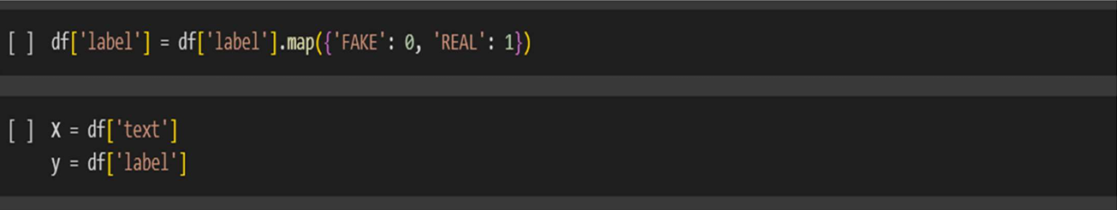

**Data Preprocessing Techniques**

Before feeding the data into machine learning models, preprocessing is necessary to clean and prepare the data. The main preprocessing steps typically include:

1. **Text Cleaning:** This involves removing unwanted characters such as punctuation marks, numbers, special symbols, and URLs. The goal is to standardize the text for analysis.
2. **Tokenization:** Tokenization refers to breaking down a sentence into smaller units, typically words or subwords, which makes it easier for a model to process the text. This step is crucial for handling linguistic data.
3. **Stopword Removal:** Common words such as “the,” “a,” and “in” do not carry much meaning in terms of content and can be removed. By eliminating these stopwords, the model can focus on the more meaningful parts of the text.
4. **Stemming and Lemmatization:** Stemming is a process where words are reduced to their root form (e.g., “running” becomes “run”), while lemmatization is more sophisticated and reduces words to their base or dictionary form. Lemmatization generally provides more accurate results, so it's preferred in text-based tasks.
5. **Text Normalization:** This can involve lowercasing all text to ensure that the model doesn't differentiate between the same word in different cases (e.g., "Fake" vs. "fake").

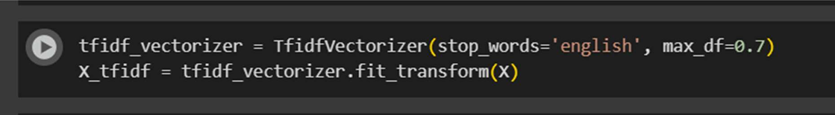

After performing these steps, we transform the text data into a format suitable for machine learning. This is typically achieved through **Feature Extraction** techniques such as **TF-IDF** (Term Frequency-Inverse Document Frequency) or **Word Embeddings** (e.g., **Word2Vec**, **GloVe**).

**Feature Extraction**

For machine learning models to work with text data, we need to convert the textual information into numerical vectors. There are two common approaches:

1. **TF-IDF:** TF-IDF represents how important a word is within a document relative to a collection of documents. It helps reduce the influence of common words and gives more importance to words that are unique to a particular article.

from sklearn.feature_extraction.text import TfidfVectorizer

vectorizer = TfidfVectorizer(stop_words='english', max_features=5000)

X = vectorizer.fit_transform(df['content'])

1. **Word Embeddings:** Embeddings like **Word2Vec** and **GloVe** are used to capture semantic relationships between words. Words with similar meanings are closer in the vector space, making them more suited for deep learning models.

**Visualizations**

Visualizing the dataset and the most frequent terms is essential for understanding the nature of the data. One popular way of visualizing text data is by creating **word clouds** that highlight the most frequently occurring words in fake and real news articles. This can give insights into the topics or phrases most common in each category.

Additionally, a **bar chart** can be used to show the distribution of fake versus real news in the dataset. This visualization helps understand how imbalanced or balanced the dataset is and what measures (like data augmentation) may be necessary to mitigate any bias.

from wordcloud import WordCloud

import matplotlib.pyplot as plt

text = " ".join(df['content']) # Assuming 'content' contains the news articles

wordcloud = WordCloud(width=800, height=400).generate(text)

plt.imshow(wordcloud, interpolation='bilinear')

plt.axis('off')

plt.show()

**4. Model Selection**

**Machine Learning Algorithms Used**

There are several machine learning algorithms that can be employed for fake news detection, depending on the complexity and nature of the dataset.

1. **Traditional Models:**
   * **Logistic Regression:** A simple linear model that is effective for binary classification tasks. It predicts the probability that an article is fake or real.

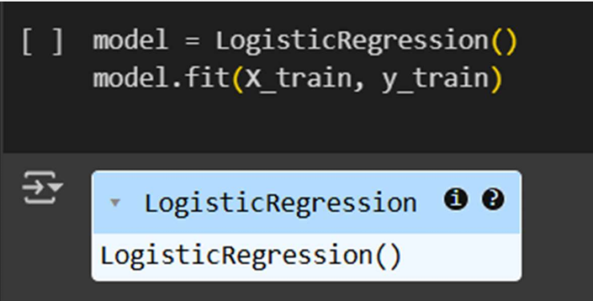

* + **Naive Bayes:** Based on the Bayes theorem, it assumes that the features are independent. It is often used for text classification tasks due to its efficiency and simplicity.
  + **Support Vector Machines (SVM):** SVM is effective for high-dimensional spaces, making it a good option when working with large, sparse text datasets.
  + **Decision Trees and Random Forest:** Decision trees can be used to split the data based on different features, while Random Forests aggregate the output of many decision trees for better accuracy and stability.

1. **Deep Learning Models:**
   * **Convolutional Neural Networks (CNNs):** CNNs are typically used for image processing but can also work well with text by treating text as a sequence of characters or words. They excel at detecting patterns in data and are suitable for fake news detection.
   * **Recurrent Neural Networks (RNNs):** RNNs are designed to work with sequences and are particularly useful for tasks involving time series or text, where word order matters. Long Short-Term Memory (LSTM) networks, a type of RNN, are more effective at handling long-range dependencies in text.
   * **Transformer-Based Models:** **BERT** (Bidirectional Encoder Representations from Transformers) has set new benchmarks in NLP. It uses attention mechanisms to understand the context of words in sentences and performs exceptionally well in tasks like fake news detection.

**Model Evaluation**

Evaluating the performance of the model is essential to understand how well it generalizes. Common evaluation metrics include:

* **Accuracy:** The proportion of correctly classified articles.
* **Precision and Recall:** Precision measures how many of the predicted fake articles were actually fake, while recall measures how many actual fake articles were detected by the model.
* **F1-Score:** The harmonic mean of precision and recall, useful when there is an imbalance in the data.
* 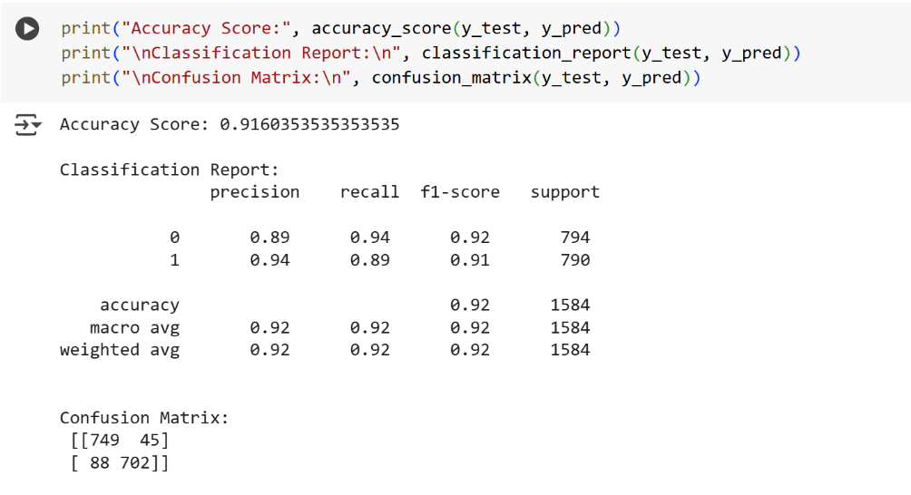**Confusion Matrix:** A matrix that shows the counts of true positives, true negatives, false positives, and false negatives.

**Code Example:**

from sklearn.svm import SVC

from sklearn.model_selection import train_test_split

from sklearn.metrics import accuracy_score, classification_report

# Splitting the data

X_train, X_test, y_train, y_test = train_test_split(X, y, test_size=0.3, random_state=42)

# Training the SVM model

model = SVC(kernel='linear')

model.fit(X_train, y_train)

# Predicting and evaluating

y_pred = model.predict(X_test)

print(f"Accuracy: {accuracy_score(y_test, y_pred)}")

print(f"Classification Report: \n{classification_report(y_test, y_pred)}")

**5. Results and Evaluation**

**Model Performance**

After training the models, it's essential to compare the results. For each model, you should evaluate its performance using the evaluation metrics mentioned previously: accuracy, precision, recall, and F1-score. The goal is to find the model that strikes the right balance between identifying fake news while minimizing false positives (real news labeled as fake) and false negatives (fake news labeled as real).

Deep learning models, especially transformers like BERT, often outperform traditional machine learning models in terms of accuracy. However, they require significantly more data and computational resources.

**Confusion Matrix and ROC Curve**

The **confusion matrix** is a key tool for evaluating binary classification models. It shows the number of true positives, true negatives, false positives, and false negatives. This matrix is essential in understanding how the model is classifying fake and real news.

Additionally, a **ROC curve** can be plotted to show the tradeoff between sensitivity (true positive rate) and specificity (1 - false positive rate). The area under the ROC curve (AUC) is a useful metric for evaluating the model's performance.

import seaborn as sns

from sklearn.metrics import confusion_matrix

cm = confusion_matrix(y_test, y_pred)

sns.heatmap(cm, annot=True, fmt="d", cmap="Blues", xticklabels=['Real', 'Fake'], yticklabels=['Real', 'Fake'])

plt.title("Confusion Matrix")

plt.show()

**6. Discussion and Future Work**

**Interpretation of Results**

Once the results are obtained, it's important to discuss what they mean in the context of fake news detection. Which model worked best? Did traditional methods such as Naive Bayes and SVM perform well compared to deep learning models like BERT?

For example, while deep learning models often outperform traditional models, they can also require significant computational resources and time to train, making them impractical for real-time detection in some cases.

**Challenges Faced**

One challenge encountered during fake news detection is **data imbalance**. A larger number of real news articles compared to fake news articles can cause the model to be biased towards the real news class. Techniques such as oversampling, undersampling, or synthetic data generation can help mitigate this.

**Future Work**

There is always room for improvement. Some future directions include:

* **Improving real-time detection** using lightweight models that can run efficiently on limited resources.
* **Incorporating multi-modal data** such as images, videos, or social media metadata (e.g., source credibility, author reputation).
* **Addressing adversarial attacks** on the detection models, as malicious entities might try to bypass the detection system by altering the content.

**Ethical Considerations**

Fake news detection models must be transparent and fair. The models should not be biased toward any particular group, and the decision-making process of the model should be interpretable.

**7. Conclusion**

Fake news detection using machine learning is a crucial task in combating misinformation and preserving public trust in news. By leveraging various machine learning algorithms, from traditional models to state-of-the-art deep learning approaches like BERT, we can build systems that are capable of distinguishing between real and fake news articles. However, challenges such as data imbalance, model complexity, and real-time detection remain significant hurdles. As the field evolves, future advancements will likely focus on improving detection accuracy, efficiency, and fairness, ultimately leading to a more informed society.

